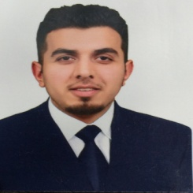 ***personal******information****:*

***Name***:Abdulah Hassan Abdulah

Birth date : 1992\8\16

***CITY*** :BAGHDAD-ALYARMOK

***Phone***: 07711611031

***EDUCATION***: -University of Baghdad— *B.Sc. Computer* (graduation_2014-2015)

***TRAINING AND CERTIFICATION:***

**CISCO_CCNA"200-125"(Routing & Switching ).**

**MIKRO TIK__MTCNA..**

**MIKRO TIK__MTCWE.**

**Ubiquiti Network.**

**Microsoft office (Word ,Excel ,Power point )**

***. TECHNICAL SKILLS*:**

**Excellent knowledge of Networking & communication : Cables, Routers, Switches, Topologies and Protocols.**

**Good knowledge of Cisco systems.**

**Good knowledge of Microsoft Windows Server 2012.**

**Have knowledge of MikroTik.**

**Excellent knowledge of Microsoft office**

**Problem Solving.**

**Attention to details.**

**Ability to handle pressure**.

***OBJECTIVE:* Seeking the position of a junior network engineer help me develop my technical abilities.**

***PERSONAL SKILLS:***

**Excellent communication and written skills as well as good organizational skill. Problem solving skills and ability to think critically. Good interpersonal skills as well as an ability to work effectively.**

***LANGUAGES :-***

"Arabic" and "English."

**:Previously Job *Experience***

1: ScopeSky Communication("Technical"OMC.dept)

2: ALMawada Security Solutions Technology & IT (IT .Dept)